| Downstream Test Plan |
| --- |
| Duck Creek - Property |
| Novemeber, 2019 Release |

|  |  |  |  |
| --- | --- | --- | --- |
| **Version** | **Date** | **Author** | **Reason for Update** |
| 1.0 | 5/30/19 | Ajay Kandukuri & Sasitha | Revised Project Schedule |

Contents

1. Introduction 2

2. Purpose 2

3. Testing Scope 2

3.1 In Scope 2

3.2 Out of Scope 2

4. Testing Milestones 3

5. Test Approach 3

6.Test Management 3

6.1 Entrance Criteria 4

6.2 Test Case Development 4

6.3 Test Case Execution 4

6.4 Types of Testing 4

6.5 Defect Lifecycle 4

6.6 Testing Metrics 5

6.7 Exit Criteria 6

7.Risks and Issues 6

7.1 Known Risks and Issues 6

7.2 Open Defects 6

8 Assumptions 6

9 Tools 6

10 Environments 6

11 Resources 7

12 Reference 7

12.1 IT QA Test Strategy 7

13 Approvals 8

# Introduction

Great American Insurance (GAI) is pursuing a speed to market strategy by purchasing the Duck Creek (DC) Policy Administration System (PAS) for the Property. The approach is of two phases with the first phase focused on a compliant product and the second phase focused on user enhancements.GAIG QA will be responsible for verifying the GAI Proprietary changes to Duck Creek, integration of Duck Creek with CUBE, data movement from E2E, and Performance of the integrated application (Duck Creek + CUBE).

# Purpose

This document describes the overall Downstream testing strategy for the Property using GAI Cube as a platform with the DC PAS. The purpose of this document is to communicate the Test Teams testing approach, to provide a high degree of assurance that the CUBE and Duck Creek applications for the Property product works as expected and integrates properly with all upstream and downstream integration points, according to the requirements, functional specifications, and designed intent.

**NOTE:** This is a living document. The document will be updated per the Lead QA Analysts discretion as more details are provided and timelines solidify.

# Testing Scope

## 3.1 In Scope

* **Validation Types**
  + Product Model / XML Validation
  + ETL Validation
  + Data Mapping Validation
  + Adapter Validation
  + Database Schema Validation
  + Enterprise Reporting Validation
  + Aggregate Calculation Validation
* **Target Systems:** EDW, FDW

## 3.2 Out of Scope

The following are considered out of scope and will not be tested:

* DC PAS Functionality
* User Acceptance Testing
* DC Third Party Integrations (Ex: MVR)
* Interface System Testing (Ex: ISO Reporting, DMV Reporting)
* URS, Claims & Billing

# Testing Milestones

As of 5/30/19; Downstream Testing testing complete 9/1/19.

Regression Testing will be ran as new code is deployed; a final run will be ran prior to UA Testing and again prior to Production Deployment.

|  |  |  |
| --- | --- | --- |
| TASK | DURATION | START DATE |
| Downstream Testing | 50 days | 7/1/19 |
| Regression Testing | 50 Days | 9/1/19 |
| Defect Remediation | 50 days | 9/1/19 |

# 5. Test Approach

* 1. **E2E Testing**

The IT Quality Assurance team will validate downstream elements that have been added, modified, or removed. Testing will include the following:

* Product Model / XML Validation: XML is created after transactions are processed and structured as specified in business rules
* ETL Validation: Data is extracted from source systems, transformed as defined by business rules, and loaded into target systems
* Data Mapping Validation: Data is stored in source systems as defined by business rules
* Aggregate calculation Validation: One to many financial aggregates are performed and stored in target systems as defined by business rules
* Target Systems
  + EDW - Validated by QA
  + FDW - Validated by QA
  + URS - Validated by Reinsurance Team
  + Claims - Validated by Claims Team
  + Billing - Validated by Billing Team

# 6.Test Management

This section details how testing will be managed. The test management process will be the responsibility of the Lead QA Analyst. The Lead QA Analyst will maintain regular communications with the Property Project Team. The stakeholders will be notified when deemed necessary.

## 6.1 Entrance Criteria

| **Type of Testing** | **Entry Criteria** |
| --- | --- |
| Smoke Test | * Policies are loaded successfully in one of the test environments |
| Regression Test | * Smoke tests have completed successfully * Regression suite is created and ready to execute |
| Functional Test/System Integration Test | * Smoke tests have completed successfully * Requirements and approach documents are base-lined and approved * Release notes with all known issues is available |

## 6.2 Test Case Development

The following test cases will be developed to provide appropriate test coverage:

* Scenario Test Cases (Having different Coverage codes)
* Each policies considered as one Test Case

## 6.3 Test Case Execution

Tests results will be stored on the Property Sharepoint site.

## 6.4 Types of Testing

Testing will be performed using functiona testing.

| **Type of Testing** | **Entry Criteria** |  |
| --- | --- | --- |
| Functional | * Manual | * Scenario Test Cases * Each policies having one test cases |

## 6.5 Defect Lifecycle

During the test execution phase, Rally is the tool that will be used to manage all defects found. The defect lifecycle will be as follows:

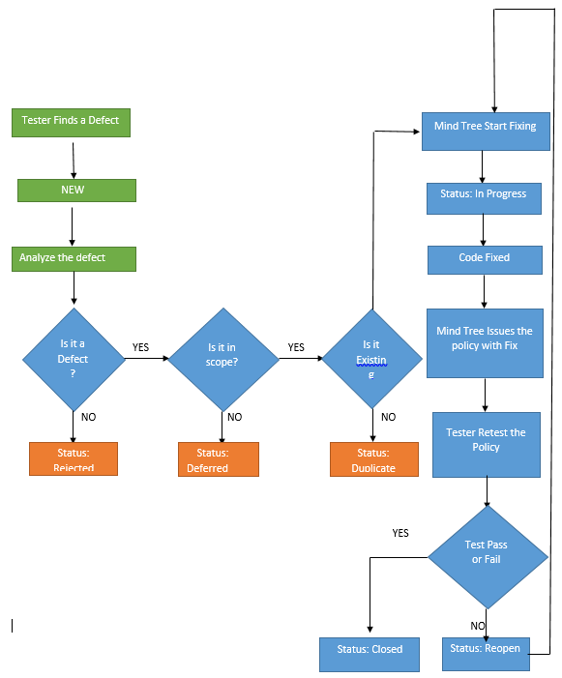

## 6.6 Testing Metrics

Testing metrics will be provided to measure and monitor testing activities. The testing metrics will be posted on the Property Sharepoint site.

## 6.7 Exit Criteria

| **Type of Testing** | **Exit Criteria** |
| --- | --- |
| Smoke Test  Regression Test  Functional Test  System Integration Test | * Test cases specified for the build have completed successfully * Defects have been resolved or have an agreed action plan * Evidence of testing is completed and published |

# 7.Risks and Issues

## Known Risks and Issues

Risks: Requirements discovery continues

Defect mitigation:

* + - Review of defects needs to be completed
    - Prioritization of defects is ongoing

## Open Defects

1. Rally
2. QA Status Report

# Assumptions

Test Environments will be available

Code delivery will be completed on schedule

# Tools

|  |  |
| --- | --- |
| **Tool Name** | **Tool Usage** |
| Rally | Test Management, Defect Management, Test Execution and Report Tool |
| TEAM | Test Case Management and Repository |
| Selenium | Test Automation |
| Jenkins/HTA | Test Execution |
| MS Excel | Test Case Development and Maintenance |
| PDF-C | Forms PDF Comparison |
| DVO | Database Comparison |
| Sharepoint | Commercial Automobile Project Repository |

# Environments

The Test Team will be dependent on other parties for the implementation of the test environment.  We expect that the test environment is stable and available for testing.

Any downtime should be planned and communicated to the Test Team so impacts can be assessed and mitigated in a timely manner.  Builds and tags should also be planned and communicated to the Test Team so impacts can be assessed and mitigated in a timely manner.

We expect that all required test data including but not limited to policy data is loaded and available in the test environment.  Likewise, we expect that all integrations required for testing are in place and working as expected.

|  |  |  |  |  |
| --- | --- | --- | --- | --- |
| **Purpose** | | **Server Name** | | **URL** |
| Remote Desktop Gateway | Remote Desktop Gateway | | uncd01.duckcreekondemand.com | |
| Database Server | UNCDEV15DATA01 | |  | |
| Sandbox Application Server (keep as base setup) | UNCDEV15APP01 | | <https://uncd60.duckcreekondemand.com/Policy/default.aspx>  <https://uncd60.duckcreekondemand.com/ServerPolicy/DCTserver.aspx>  <https://uncd60.duckcreekondemand.com/UserAdminPolicy/Default.aspx> | |
| Dev/QA Application Servers | UNCDEV15APP02 | | <https://uncd61.duckcreekondemand.com/Policy/default.aspx>  <https://uncd61.duckcreekondemand.com/ServerPolicy/DCTserver.aspx>  <https://uncd61.duckcreekondemand.com/UserAdminPolicy/Default.aspx> | |
| TBD | UNCDEV15APP03 | | <https://uncd62.duckcreekondemand.com/Policy/default.aspx> <https://uncd62.duckcreekondemand.com/ServerPolicy/DCTserver.aspx> <https://uncd63.duckcreekondemand.com/UserAdminPolicy/Default.aspx> | |
| TBD | UNCDEV15APP04 | | <https://uncd63.duckcreekondemand.com/Policy/default.aspx><https://uncd63.duckcreekondemand.com/ServerPolicy/DCTserver.aspx><https://uncd63.duckcreekondemand.com/UserAdminPolicy/Default.aspx> | |
| TBD | UNCDEV15APP05 | | <https://uncd64.duckcreekondemand.com/Policy/default.aspx>  <https://uncd64.duckcreekondemand.com/ServerPolicy/DCTserver.aspx>  <https://uncd64.duckcreekondemand.com/UserAdminPolicy/Default.aspx> | |
| TBD | UNCDEV15APP06 | | <https://uncd65.duckcreekondemand.com/Policy/default.aspx>  <https://uncd65.duckcreekondemand.com/ServerPolicy/DCTserver.aspx>  <https://uncd65.duckcreekondemand.com/UserAdminPolicy/Default.aspx> | |
| TBD | UNCDEV15APP07 | | <https://uncd66.duckcreekondemand.com/Policy/default.aspx>  <https://uncd66.duckcreekondemand.com/ServerPolicy/DCTserver.aspx>  <https://uncd66.duckcreekondemand.com/UserAdminPolicy/Default.aspx> | |

*Email to Sean Kellner for CUBE Integration environment set up.

# Resources

Ajay Kandakuri - Data Analyst

Selvaraj Sasitha – Data Analyst

# Reference

## **12.1** IT QA Test Strategy

**Package SharePoint**

# Approvals

|  |  |  |  |
| --- | --- | --- | --- |
| **Name** | **Role** | **Signature** | **Date** |
| Vidal Carrie | Project Manager |  |  |
| Penny McVay | QA Manager |  |  |
| Galle Suzzane | QA Lead |  |  |